**Recommendation**

* Continue to push produce items (bananas)
* Add a promotion/sale for weekends (including Friday’s)
* Add a promotion/sale (‘Happy Hour Sale’) for between 10am – 2pm everyday

**Justification**

Orders

The results of figures 1 and 2 display the average number of days between orders for the top customers (Figure 4) and then days between orders for all customers. These two results help you get a better understanding of how long it takes to expect a customer to come back depending on past behaviors. This can also help you better gauge how you want to handle your top customers. Figure 3 displays the top sixteen hours across the week that are most popular. You can use this information to make decisions about certain hours regardless of day or look at the trends of the days themselves. With data that included timestamps, we can dive deeper into this topic and find more trends based on the period we want to observe.

User’s Purchasing Behavior

Figures 4 and 5 give you a better understanding of the behaviors of your top customers and who they are. Figure 4 gives you a list of all the customers who have made at least 100 orders with Instacart. Figure 5 then gives information about the longest time between orders for these customers. This gives you a better understanding of how long you should expect to wait at most for your top customers to return, and some feeling for how to keep that number low. Figure 6 is tasked with allowing you to observe purchasing habits between the weekdays and the weekend. Even though the weekend (Saturday and Sunday) only makes up 28.57% of the total time in the week, it is responsible for 36.38% of all orders. Prioritizing the weekend since it brings in a higher ratio of the orders relative to days it takes up could be beneficial. Like Figure 6, Figure 7 looks at another comparison. This time it compares daytime (8am-5pm) to nighttime (6pm-7am). Not surprisingly, the daytime is responsible for most of the orders. When you consider Figure 3 in its entirety, it lets you know that 10am-2pm is the most popular time to make orders through Instacart.

Products

Figures 8 and 14 deal with solely products. It allows us to see not only what are the most often ordered products, but also what are the most often reordered products. There is some overlap which is to be expected but there is a handful of differences which could give valuable insight into what products are really enjoyed when they are ordered the first time. Looking at Figure 14 can help you get a better understanding of that. Figure 13 does a wonderful job of relaying to us what it is that customers want to make sure they get in the cart. Displaying the most often products that are put in the cart first allows us to gather what items are most important. Produce is once again well represented, but also organic products are at the top of the list. This could give some insight into how customers view organic products.

Figure 9 displays the most popular departments for Instacart orders. We should not be surprised to see produce at the top of this figure. Produce had the highest selling products, so to see that the department overall was the highest selling should come as no shock. In a similar process to earlier, we take things a step further when looking at products. This time we found the top products that were ordered (Figure 11) and reordered (Figure 16) in each department. This helps you get a better breakdown of what sells well in what section. You can use this information to potentially do promotions for certain departments.

To help further justify that produce is the best-selling department, we found the top three aisles overall (Figure 12). All three of them have to do with either fruit or vegetables. As shown in the figure, those three aisles make up for 18% of the total products purchased when there are 134 aisles to choose from. Like previously we take it even a step further. Now we are looking at specific aisles and their products in each department that sell best (Figure 10). Once again, aisles with produce perform the best relative to the whole store. This is the case for both orders and reorders (Figure 15). This also helps explain why the produce department overall does such an excellent job.

To really take a dive into the comparison of organic vs non-organic, we wanted to see if each were being purchased at a rate consistent with their availability (Figure 17). We noticed that about 85% of all products offered were non-organic, with the other 15% being organic. What surprised us, however, was that of the products ordered, organic made up 29% of all items bought. This tells us that even though organic did not comprise much of the selection, it was bought at a higher rate.

**Appendix A: Questions about orders**

 

**Figure 1. Average Days Between Orders** **For Top Customers**  **Figure 2. Average Days Between Orders**

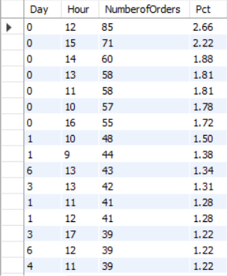

**Figure 3. Orders** **By Each Hour** **Of Each Day**

**Appendix B: Questions about users’ purchasing behavior**

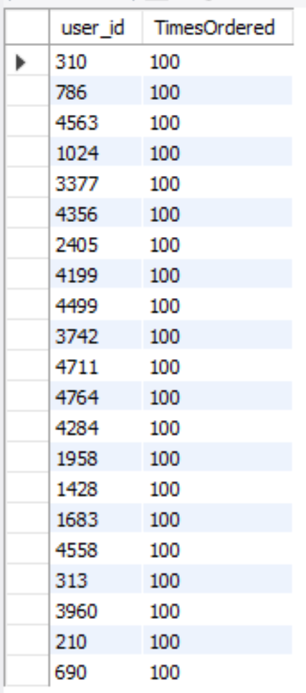 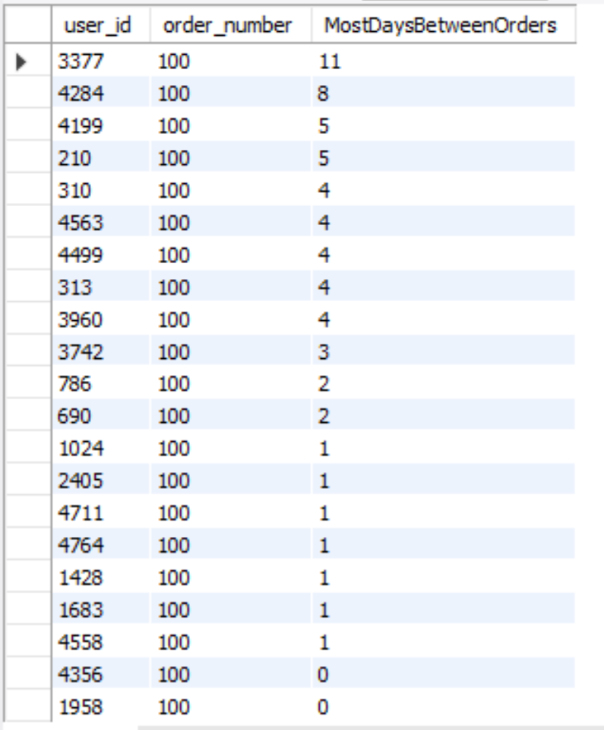

**Figure 4. Most Common Users** **Figure 5. Max Days Between Orders** **For Top Users**

 

**Figure 6. Weekday vs Weekend**  **Figure 7. Daytime vs Nighttime**

**Appendix C: Questions about products**

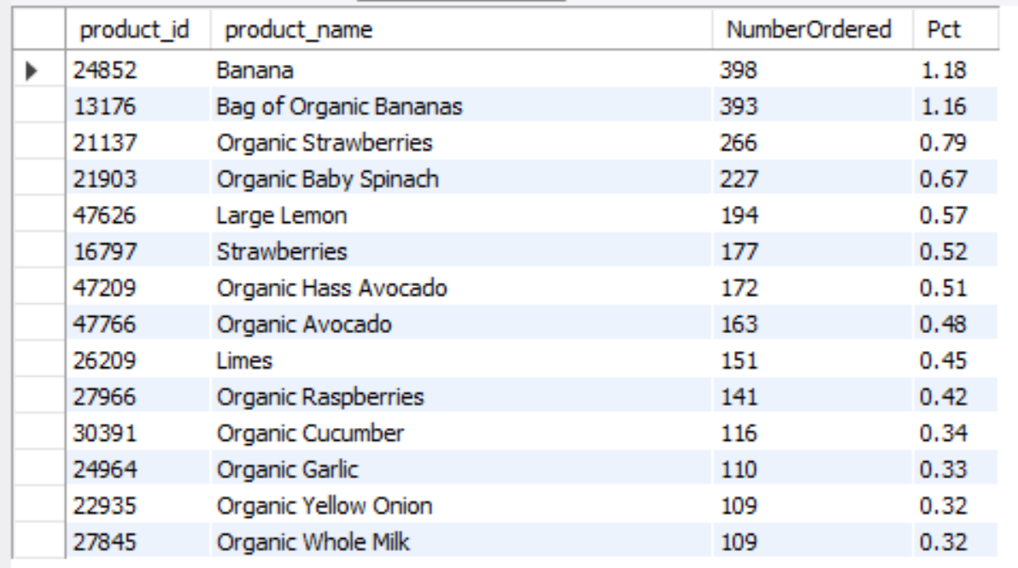 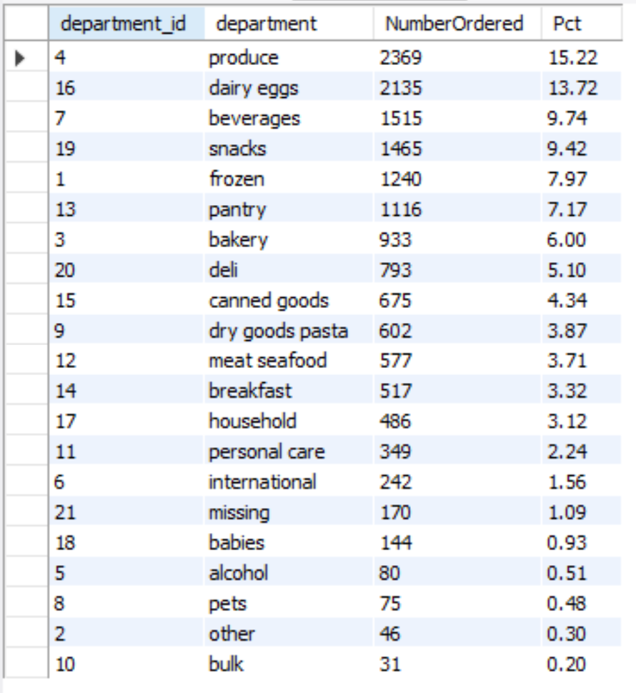

### **Figure 8. Most Popular Products** **Figure 9. Most Popular Department**

### 

### **Figure 10. Most Popular Product by Aisle Figure 11. Most Popular Product by Dept.**

### **Figure 12. Most Popular Aisles** Figure 13. Product Ordered First

### 

### Figure 14. Top 10 Reordered Products

### **Figure 15. Most Reordered Product by Aisles Figure 16. Most Reordered Product by Dept.**

### 

### Figure 17. Organic Vs. Non-organic Products (Offered vs. Ordered)